**How to download and connect APP**

**APP for Android Mobile：**

**Note: You need to enable the location information before connecting to HM-10 Bluetooth module via cellphone, otherwise, Bluetooth may not be connected.**

Enter Google play，search “keyes IoT”，if you can’t search it on app store, please download the app：

<https://play.google.com/store/apps/details?id=com.keyestudio.iot_keyes>

After installing and open the app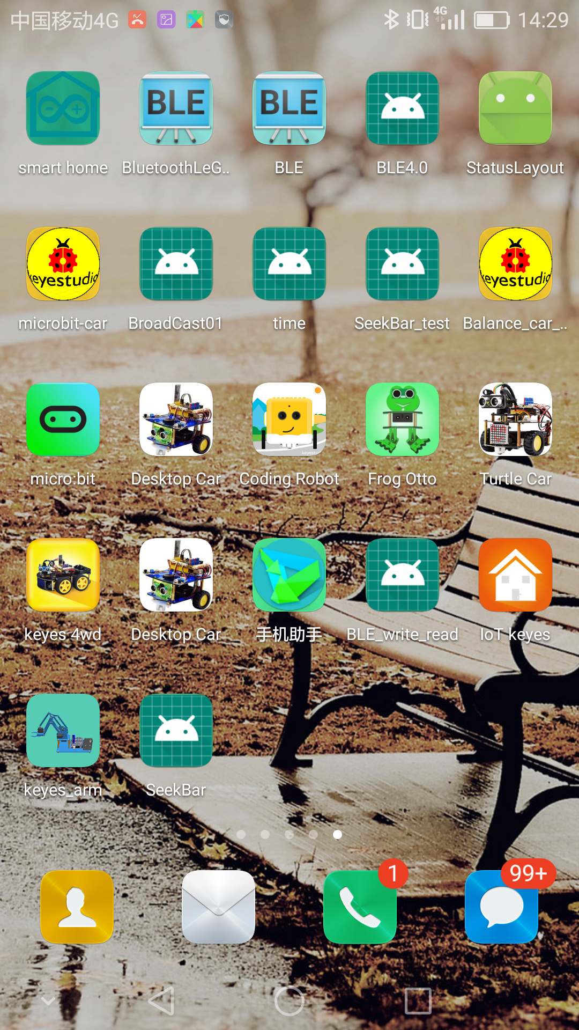，the interface pops up as below:

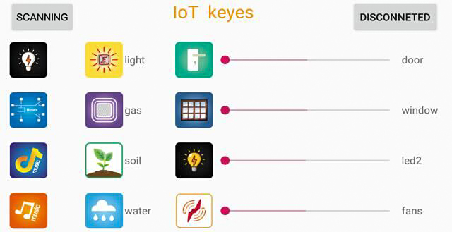

Upload code and power on, LED of Bluetooth module blinks. Start Bluetooth and open App to click “SCANNING” to search and connect.

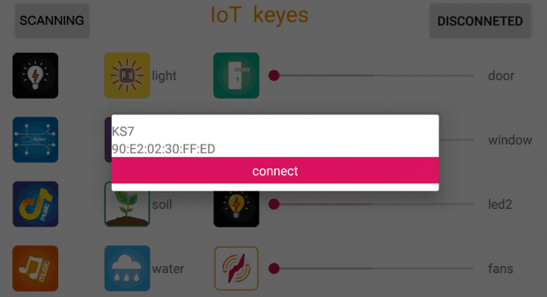

Click to “Connect”, Bluetooth is connected successfully. As shown below, the LED of Bluetooth module is always on.

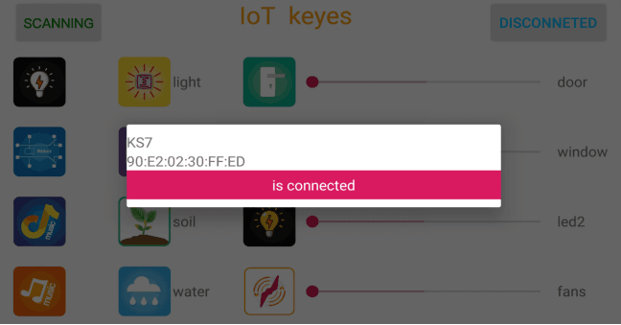

1. **iOS System：**

(1) Open App store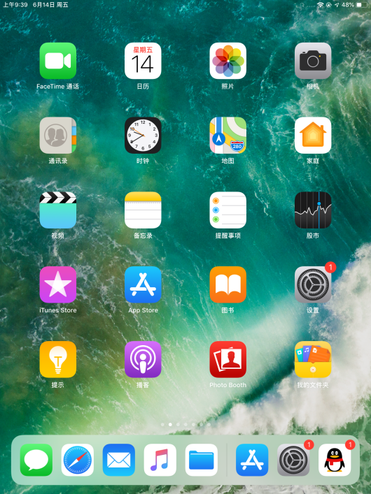

1. Search “IoT keyes”on APP Store，then click “download”.

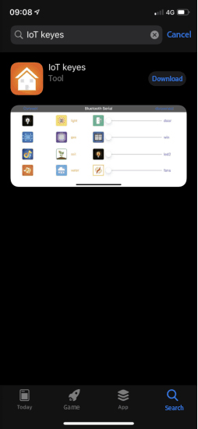

1. After installing successfully and open，the interface is shown below:

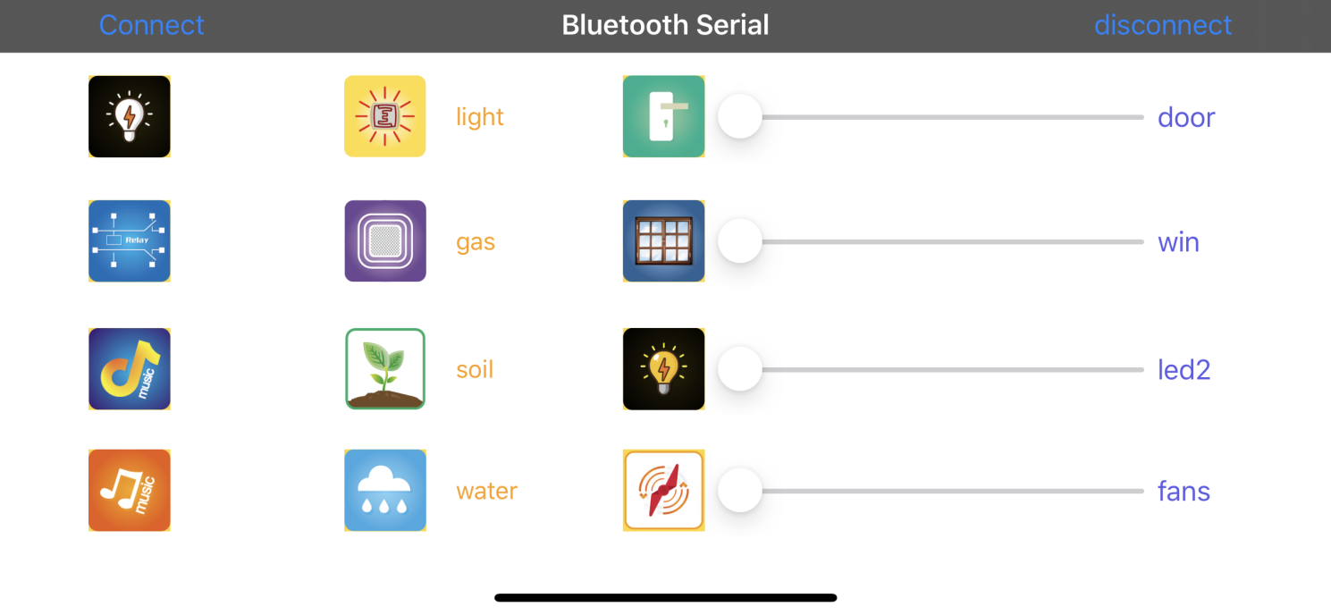

(4) After uploading the test code successfully, insert the Bluetooth module and power on. LED of Bluetooth module flashes. Start Bluetooth on cellphone, click “connect” to search Bluetooth and pair. After paring successfully, the LED of Bluetooth module is always on.

Note: Remove the Bluetooth module please when uploading the test code. Otherwise, the program will fail to upload. Connect the Bluetooth and Bluetooth module to pair after uploading the test code.